CSA1708-ARTIFICIAL INTELLIGENCE
LAB EXPERIMENTS
Program 9 : Python Program to Solve the Travelling Salesman Problem
Aim
To find the shortest round-trip route that visits each city once and returns to the starting city.
Algorithm
1. Read the number of cities and their distance matrix.
2. Generate every possible route starting from city 0.
3. Calculate each route's total distance, including the return to city 0.
4. Keep the route with the smallest total distance.
5. Display the best route and its distance.
Program
from itertools import permutations

number_of_cities = int(input("Enter number of cities: "))
distance = []
print("Enter the distance matrix row by row:")

for i in range(number_of_cities):
row = list(map(int, input().split()))
distance.append(row)

cities = list(range(1, number_of_cities))
best_cost = float("inf")
best_route = None

for route in permutations(cities):
path = (0,) + route + (0,)
cost = sum(distance[path[i]][path[i + 1]]
for i in range(number_of_cities))

if cost < best_cost:
best_cost = cost
best_route = path

if best_route is None:
print("No route found.")
else:
print("Best route:", best_route)
print("Minimum distance:", best_cost)
Sample Input
Number of cities: 4
0 10 15 20
10 0 35 25
15 35 0 30
20 25 30 0

Program Execution
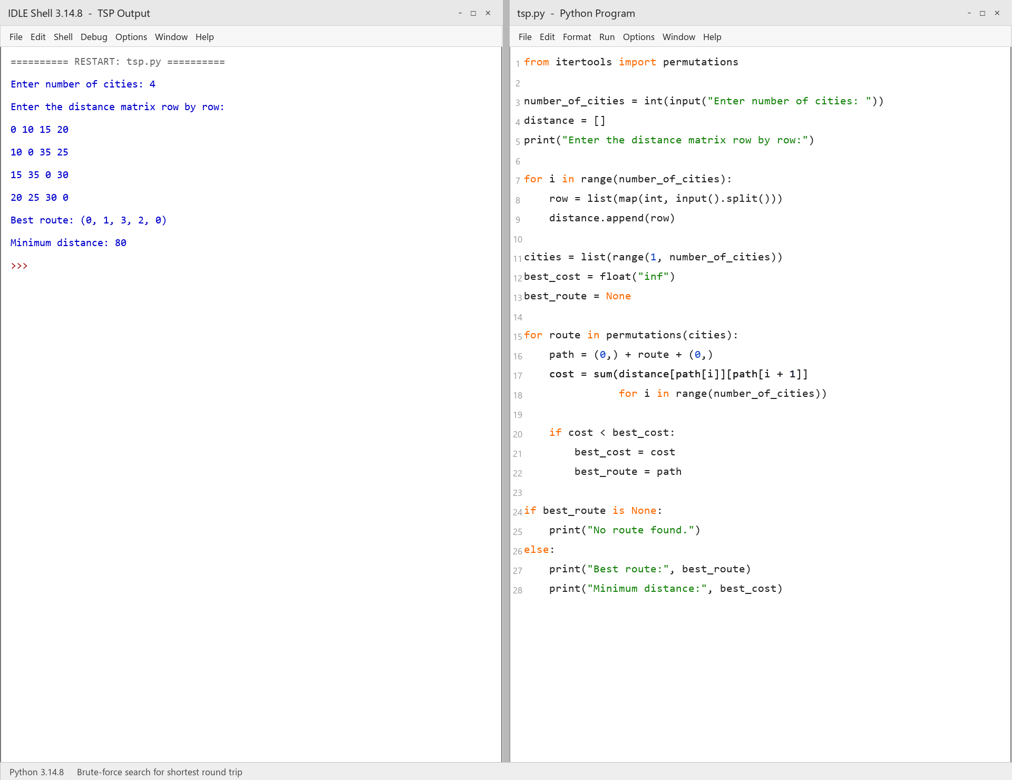

RESULT
Thus, the Travelling Salesman Problem was solved successfully using Python.

